**PRACTICAL 4**

**CISM 314**

**24 MAY 2018**

**GROUP MEMBERS**

1. **MOLEMA R 28326946**
2. **NYAMENI M.P 27191176**
3. **MOOKETSI T.P 28015207**

Introduction

The practical is based on developing a complier that understands basic add and subtract operations, done with the simple use of a register.

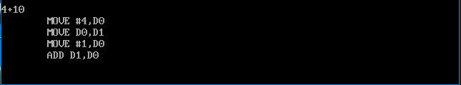

Figure 1. Addition

The figure above shows the addition operation when adding two numbers.

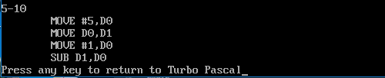

Figure 2. Subtraction

The figure above shows the subtraction operation when subtracting one number from another number.